Backstreet Performing Arts Presents:
“ Timeless ”
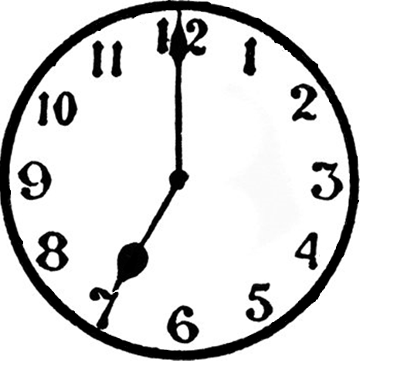
A Dance Recital
Timeless is the theme of this year’s dance recital. We will be dancing and acting as we move through decades of dance and music. ALL dancers are welcomed, no matter the level of dance and ability, to join us in this journey.
Students are required to: keep tuition up-to-date, a complete commitment form (available in the office), purchase a costume, pay a recital fee, attend classes, and participate during dress rehearsal (Thursday, July 27th) and the two performances (Friday, July 28th and Saturday, July 29^{th).} This is an amazing opportunity for dancers of all ages to be able to show-off the different techniques they have been learning during class.
We will have a professional photographer, Sunshine Studios, and the opportunity to volunteer posted closer to the event. Students will be doing most of their rehearsals during their class times; there may be some extra practice closer to the show. Keep checking your email, Facebook, and the studio for updates!

BACKSTREET PERFORMING ARTS RECITAL “TIMELESS” COMMITMENT FORM
Dear Parents and Dancers:
Our recital will be held Friday, July 28th @ 7:00 pm, and Saturday, July 29th @ 2:00 pm at Arlington High School. Please be aware all dancers will need to participate in the dress rehearsal, Thursday, July 27th, and perform in both shows. Please check the parent’s board, windows, your e-mail, Facebook, Website, etc. for all information so you can keep yourself informed on what is happening. If you have not ever received an email, please check in with the office to make sure your email is correct. Always feel free to contact the office if you have any questions.
PLEASE INITIAL THE FOLLOWING AND RETURN TO THE STUDIO BY May 1st.
_____REHEARSALS will be held in all classes and will continue up to the show. The schedule for rehearsal dates and other important dates will be posted throughout the studio, emailed, on Facebook, and posted on the website as updates continue.
_____COSTUMES: Every student will need to purchase one costume (with the exception of those ONLY in tumbling/ACRO). The cost will be $65. (If you are ONLY in tumbling/ACRO, you will be given instructions on costuming at a later time.) This fee is due by: May 1st.
_____RECITAL FEE OF $25 PER DANCER IS REQUIRED. This will be due by June 15th . This includes a program, snacks, water, and craft activities provided in the dressing room area.
_____TUITION: All accounts must be current for dancers to perform in the show. There will be no exceptions.
_____TICKETS: Tickets will be on sale starting July 15th for $20 per adult/$10 per child 10 years and under. Performers do not buy tickets. Performers are supervised backstage during the performance. Audience members are HIGHLY ENCOURAGED to stay for the duration the recital as a sign of respect for all dancers. Also, every dancer will be involved in the opening and closing numbers. A ticket must be purchased for everyone else who is attending for each of the two shows.
____PHOTOGRAPY: No photography will be allowed during the performances.
Student’s Name:________________Parent’s Name________________
CLASS: _______________________ DAY/TIME___________________ TEACHER_______________
CLASS: _______________________ DAY/TIME___________________ TEACHER_______________
CLASS: _______________________ DAY/TIME___________________ TEACHER_______________
____NO, we will be unable to participate in the recital this year.
Parents Signature_____________________________________

